How to mat a photo for ARS rose shows

Materials needed:
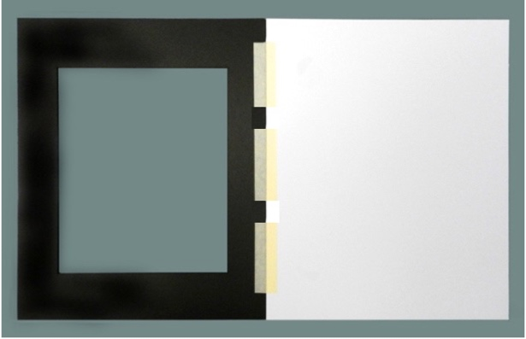
- 8” x 10” photo
- 11” x 14” mat board (backing) & 11” x 14 front mat
- Masking tape
- Pencil
- Scissors
- Artist’s mounting tape (removable so it can be adjusted easily) ½” or wider

Step 1: Place front mat face down and the back mounting board face up so that the top edges are touching and line up. This may be horizontal or vertical depending on the photo. Place masking tape along this edge cutting it just short of the edges. This will act as a hinge for the mat.

Step 2: Close the mat and place the photo inside and position it so that it is inside the opening and best displays the photo.

Step 3: Hold the photo down and carefully lift the front mat. Mark the top corners of the photo. Then flip the photo up and place the corners on the markings you made. Apply 3 pieces of the artist mounting tape as in the diagram so that you create hinges when it is folded back.

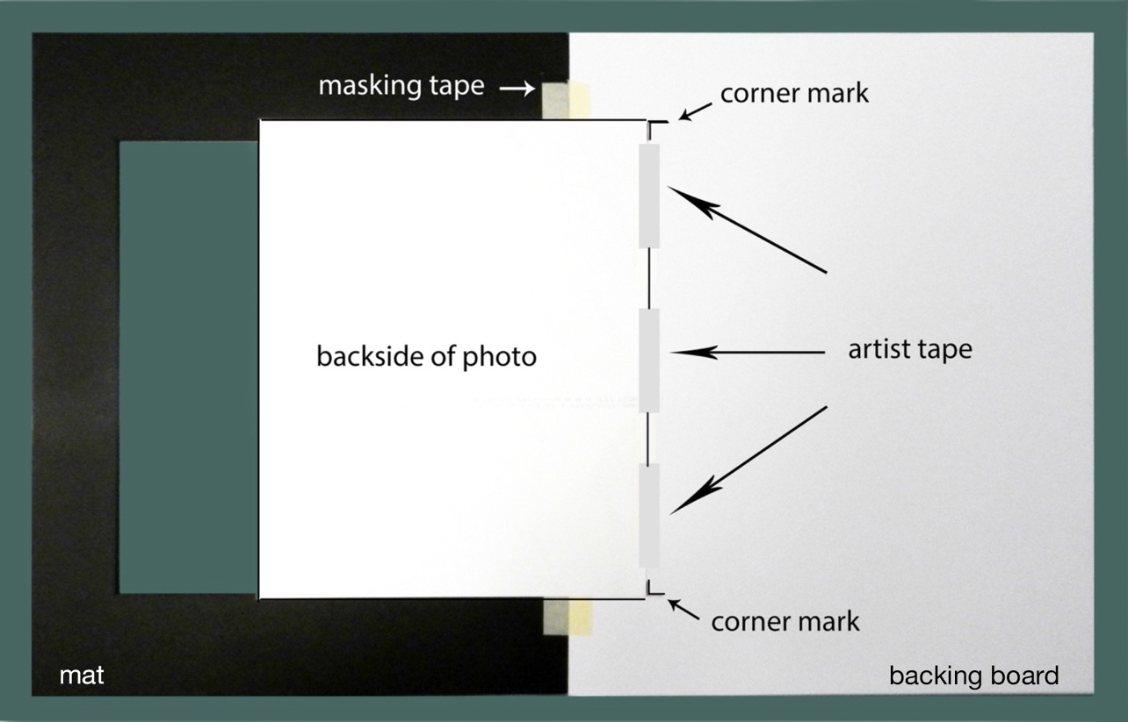

Step 4: Fold back the photo and then the mat and you are done!

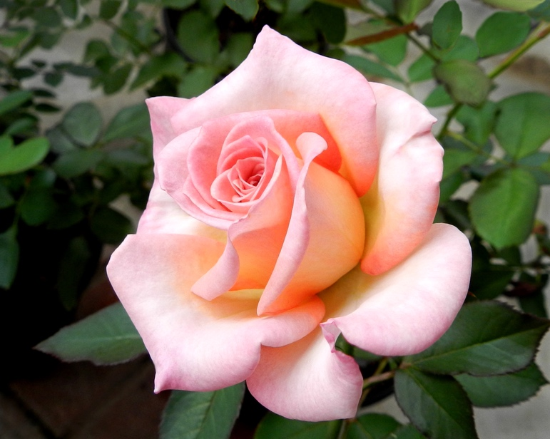

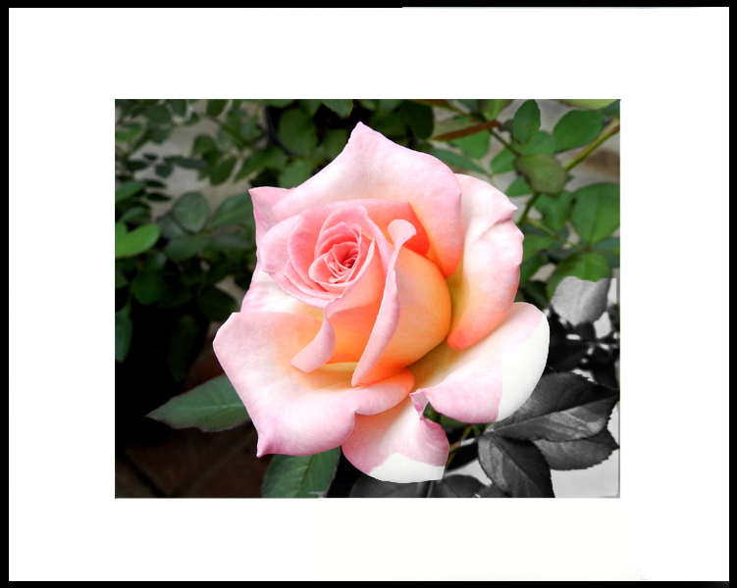

Where to purchase needed materials

Photo Mats & Backing Boards

Can be purchased on Amazon. Some sellers are good, but others are not. I recommend those made by Golden State Art. Choose: Acid free, 11x14 with bevel core cut for 8x10 photos with backing boards. Be sure it includes backing boards. If you buy them separately, they may not match up as well. You can usually get them in packs of 10 or 25. Many judges do not like colored mats, so I recommend that you stick with white.

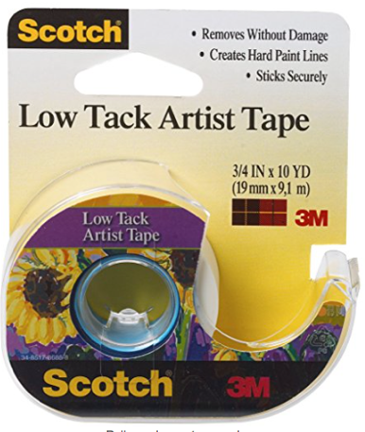
Artist Mounting Tape

Something like Scotch Low Tack Artist Tape ¾ “ x 10 yards (under $5)

Barbara Lester - 2023

